**Change Man**

**Nordic Changeman Packages –**

**DK814 :** DK01

**DK817 :** DK02

**LV823 :** LV23,ND23(Old Latvia)

**Changeman Shortcuts**

1.

**TSO CMN1/TSO CMNT**

For going into changeman screen

2.

**5 List**

To go to package and view the package list

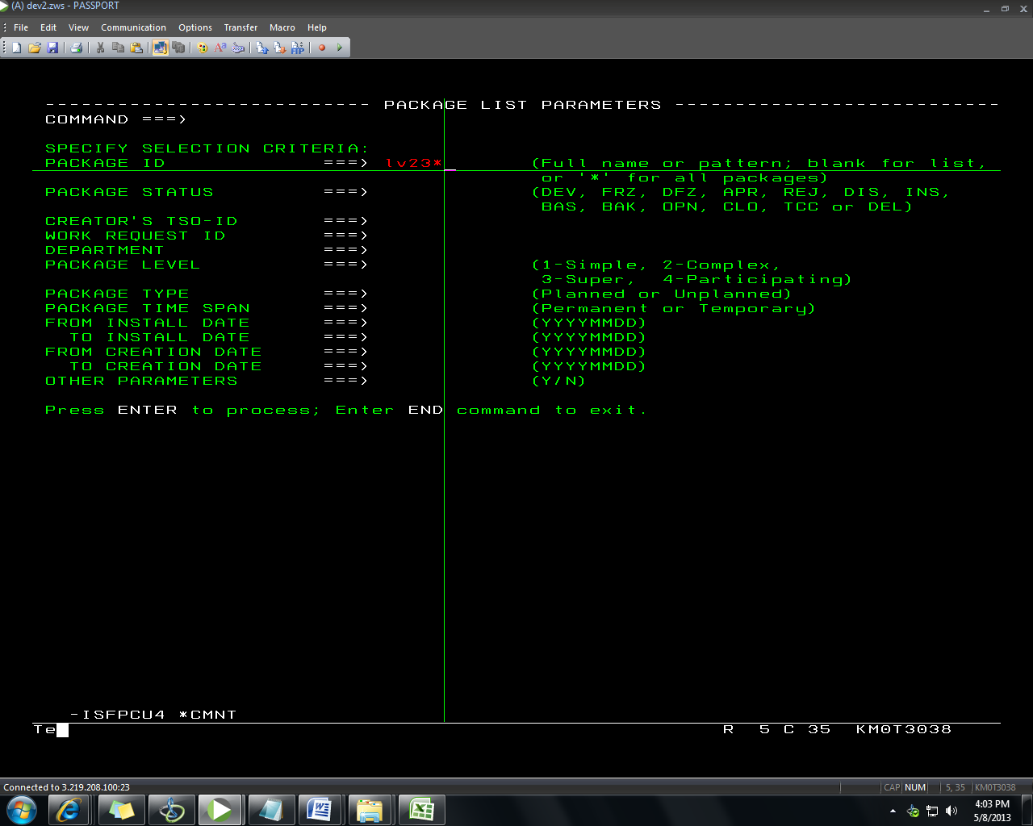

3.

**1 Build --> 1**

Create a package

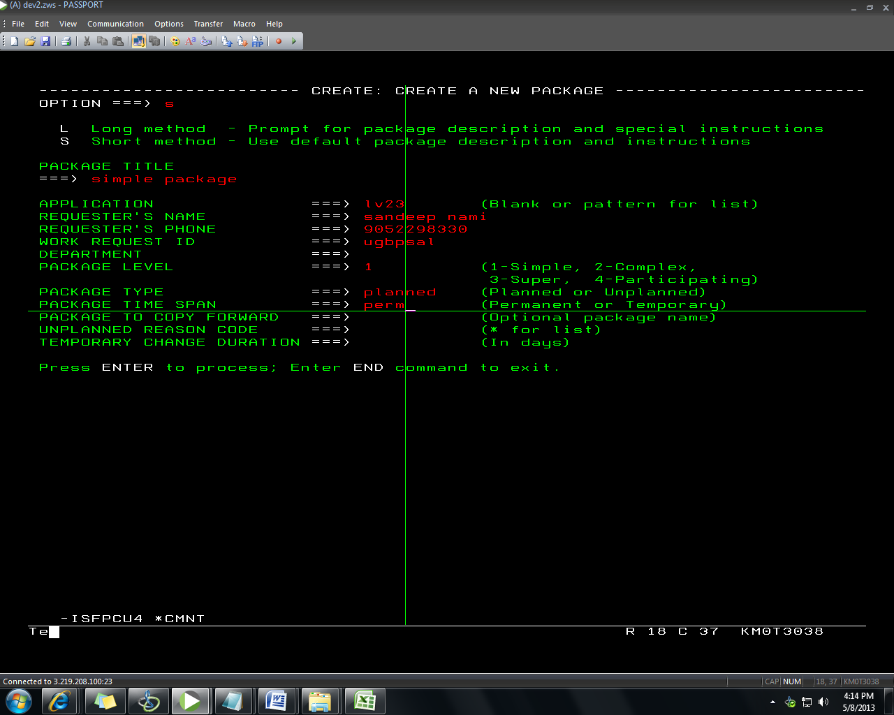

4.

To know all the commands assosciated with the package give **? and Press Enter**

**C1**

checkout components

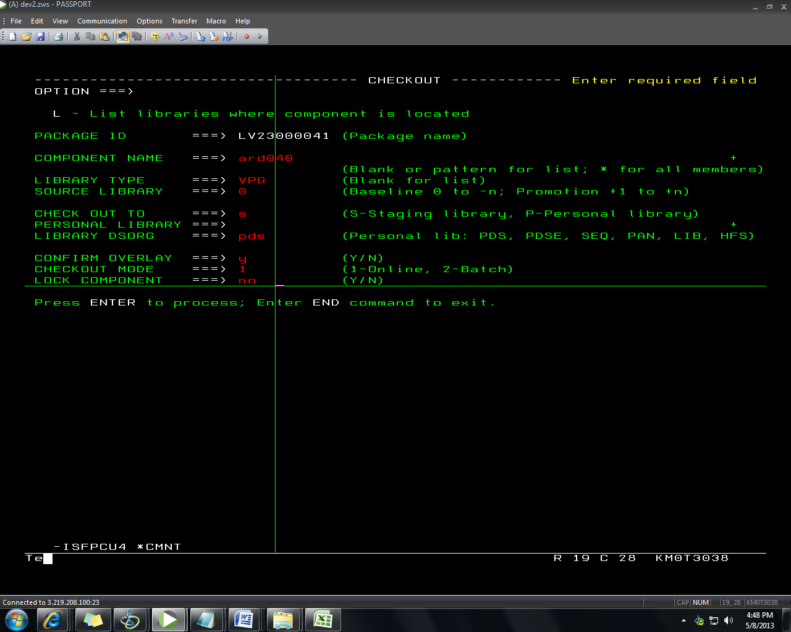

5.

**S1**

Stage components from your library

6.

**S2**

browse components

7.

**R**

RECOMPILE

8.

**S**

Compile

9.

**Ap**

Audit the package before baselining.

**10.**

**F1**

Freeze the package

**11.**

**A1**

Approve the package(Baseline the package)

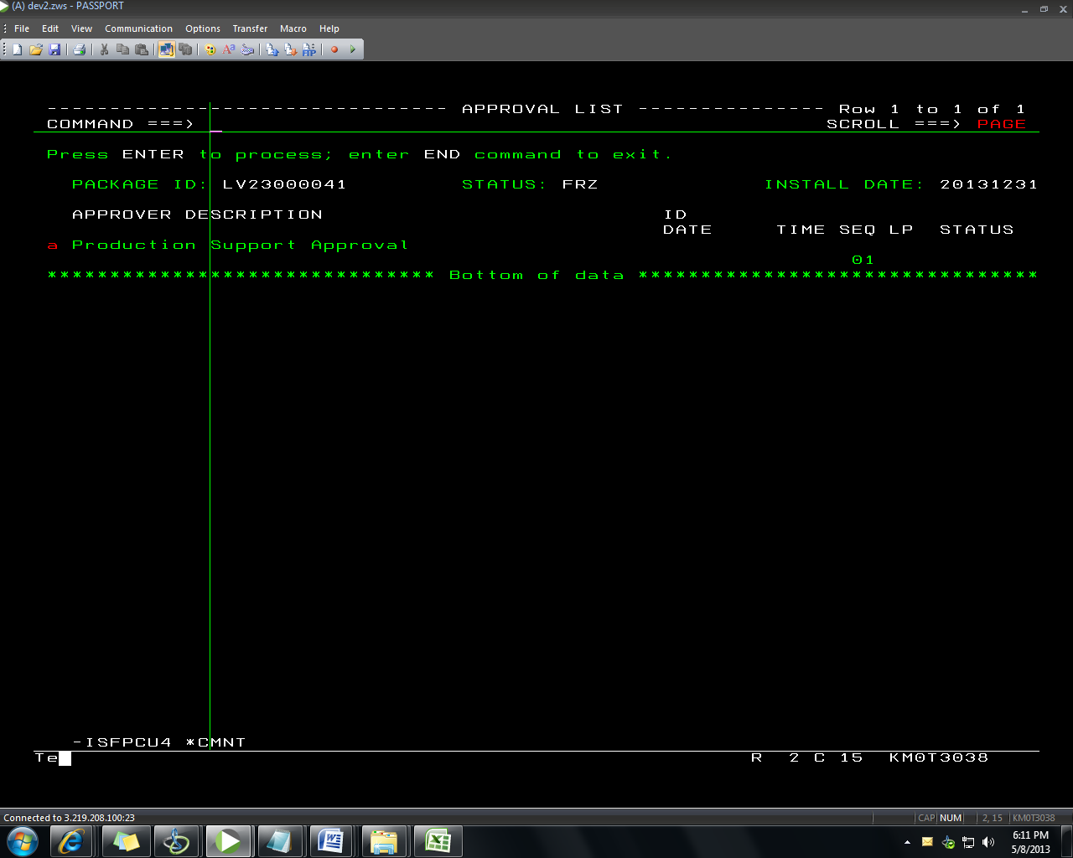

12.

B1

For backing out baselined packages

13.

RV

For Reverting the status

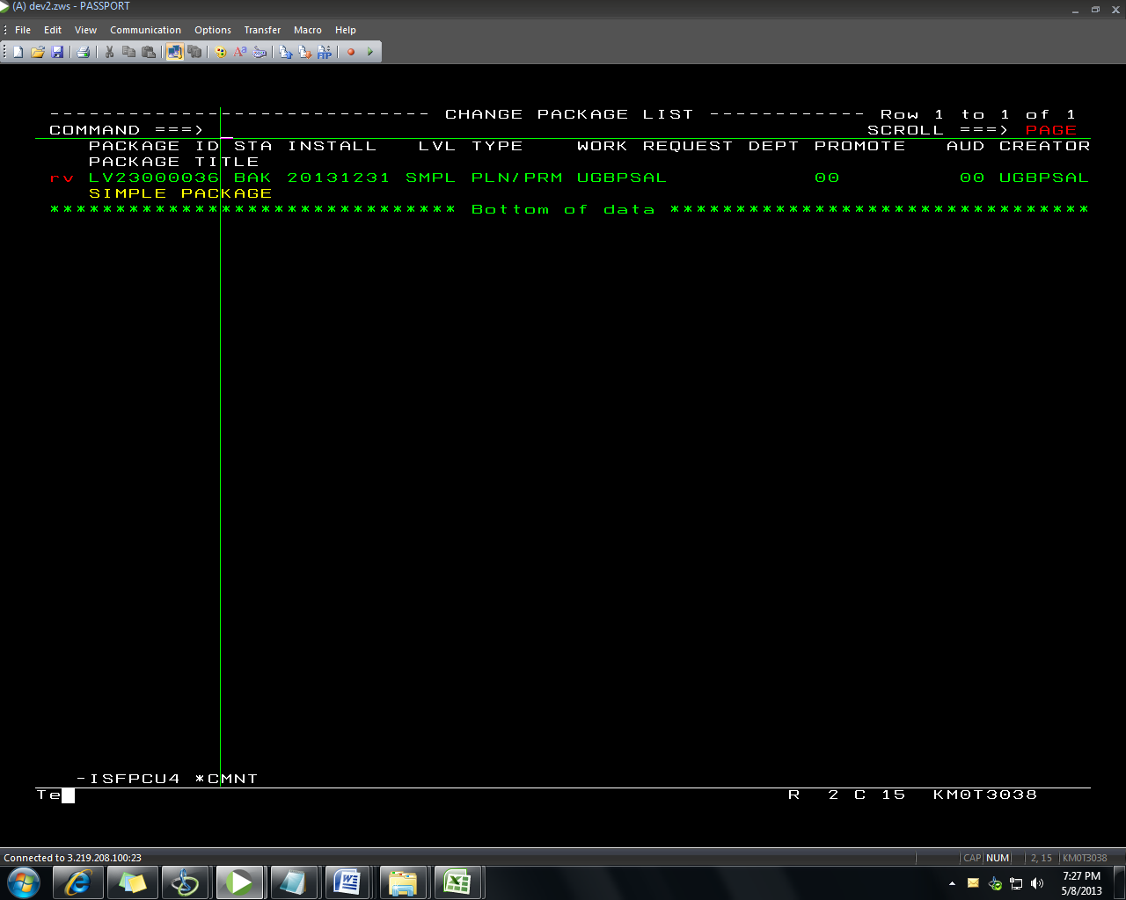

14.

D1

For deleting package

8.

**V**

VIEW

10.

**E**

EDIT

**11.**

**Short**

Show description of the package in short form

**12.**

**Long**

Show description of the package in Long form